**ABSTRACT**

**Title** : Smart Product Recommendations

**Topic :** Integration of Artificial Intelligence with E-Commerce

This project focuses on developing a **Personalized Recommendation Module** using Artificial Intelligence and Machine Learning (AIML) to enhance the user experience in e-commerce. The module aims to suggest relevant products to users based on their past interactions, preferences, and behaviors, thereby increasing engagement and sales.

The recommendation system will utilize **collaborative filtering** and **content-based filtering** techniques. Collaborative filtering predicts a user's interest by analyzing patterns from similar users, while content-based filtering recommends products based on the features of items the user has previously interacted with in the time period of usage.

The project will involve collecting and preprocessing data, such as user purchase history, user purchase interest, product ratings, and browsing behavior. Machine learning algorithms will be trained on this data to recognize patterns and make accurate predictions of the recommended products as per the customers interest in the purchasing and sales . The performance of the model will be evaluated using metrics like **precision** and **recall** to ensure the recommendations are relevant and useful for the customer according to their needs of purchasing.

This Personalized Recommendation Module will be integrated into the e-commerce platform, providing tailored product suggestions that enhance customer satisfaction and drive sales. The model will be continuously updated with new data to adapt to changing user preferences and improve recommendation accuracy within the time period of the customers usage.

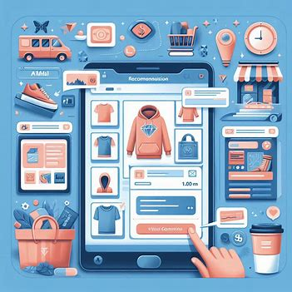

The Personalized Recommendation w.r.t customers interest

The success of this project will demonstrate the potential of AIML in creating personalized experiences, ultimately leading to higher customer retention and increased revenue for the business and the customers interest in the particular product background for its ease to use.

Team Members:

1. Prajwal Auradkar (2320040084)
2. Peddigari Chetan (2320040067)
3. V. Ravi Kiran (2320040081)